HP Wolf does THIS!!!!

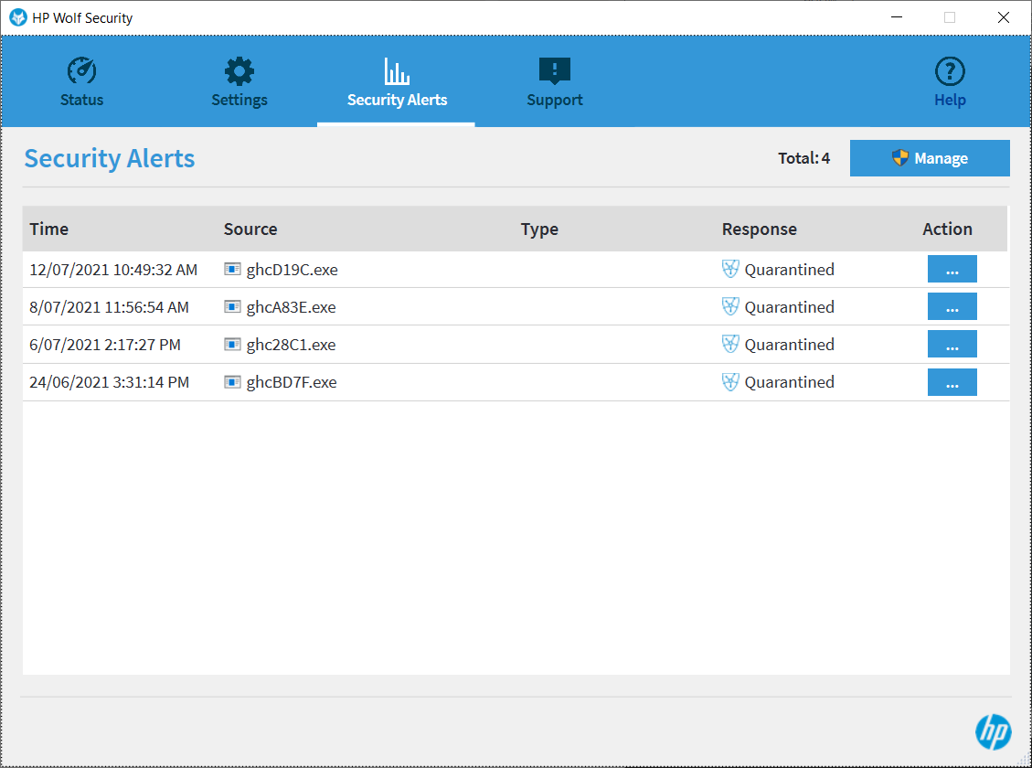

Installed on 25/5/2021

To get rid of it, use apps